Giving of Tithes and Offerings (Choir Anthem)

* Doxology - Glory to God Hymnal #606

* Prayer of Dedication

* Hymn #306 (Glory to God Hymnal) “Blest Be the Tie That Binds”
* Benediction
* Choral Benediction
The Postlude

Session
Brook Bockhorn Marvin - Christian Education
Scott Carlson - Mission & Benevolence
Elizabeth Smith Lehrmann - Congregational Care
Jerry Newman - Worship
Tom Newman - Building & Grounds
Geneva Aguilar Winkelmann - Fellowship, Church Growth
Clerk to Session: Rosellyn McIver and Interim Treasurer: Todd Gray

Today’s Liturgist: Geneva Winkelmann

We welcome to our pulpit a long-time friend of the congregation,
the Reverend Randy Wells.

Our Mission Statement
Gather to worship God and know His Word
Grow in our relationship with God
Go into the world to serve

www.brenhampresbyterian.org

*Congregation please stand

Brenham
Presbyterian Church
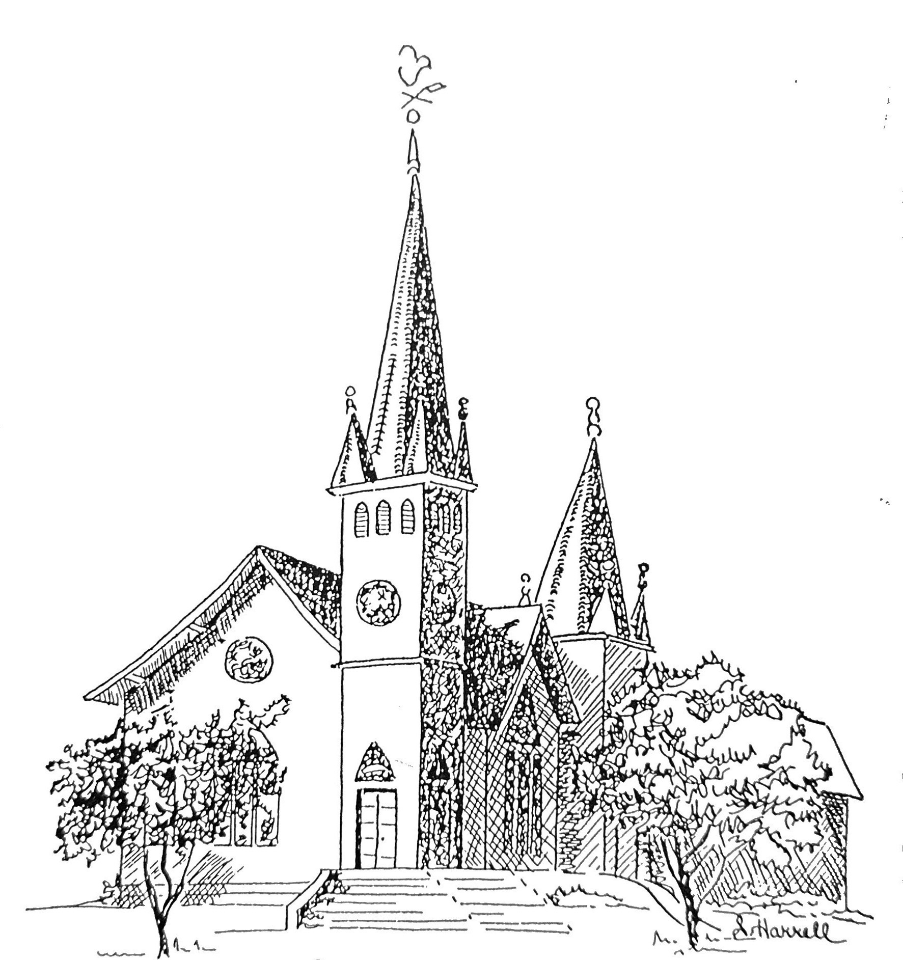
Founded 1877

Brenham Presbyterian Church
Order of Worship
April 21, 2024
Fourth Sunday of Easter

Welcome and Announcements
The Prelude
Tolling of the Bell

Call to Worship
Leader: I will extol you, my God and King, and bless your name forever and ever.
People: Every day I will bless you, and praise your name forever and ever.
Leader: Great is the Lord, and greatly to be praised;
People: His greatness is unsearchable.
Leader: Our help is in the name of the Lord who made heaven and earth.
People: Let us worship God. (Psalm 145:1-3)

* Opening Hymn #100 (The Hymnbook) “All Creatures of Our God and King”

* Prayer of Adoration (unison)
O God, who has prepared for those who love you such good things as pass
our understanding: Pour into our hearts such love toward you and toward our
neighbors, that we may become what we are in Jesus Christ: your children.
We ask this in the name of him who has called us also to follow, even Jesus Christ
our Lord. Amen.

Assurance of Pardon: The Lord is merciful and gracious, slow to anger, and plenteous in mercy. He has not dealt with us after our sins, nor rewarded us according to our iniquities. As the heaven is high above the earth, so great is His mercy toward them that fear Him.
As far as the east is from the west, so far has He removed our transgressions from us.
(Psalm 103)

Prayer of Confession (unison) Almighty and most merciful Father: we have erred and strayed from your ways like lost sheep. We have followed too much the devices and desires of our own hearts. We have offended against your holy laws. We have left undone those things which we ought to have done; and we have done those things we ought not to have done; and there is no health in us. Have mercy upon us, O Lord. Spare those who are penitent according to your promises declared unto mankind in Christ Jesus our Lord. And grant, O most merciful Father, for his sake, that we may hereafter live a godly, righteous, and sober life; to the glory of your holy name. Amen.

The Commandments (unison)
We love God because he first loved us. Those who say, “I love God,” and hate
their brothers or sisters, are liars; for those who do not love a brother or sister
whom they have seen cannot love God whom they have not seen. The
commandment we have from him is this: those who love God must love their
brothers and sisters also. (I John 4:19-21)

Musical Reflection

Unison Scripture Reading (Selection 60) - Page 531 in the back of The Hymnbook

* Hymn #483 (The Hymnbook) “O God of Love, O King of Peace”

Prayer of Illumination

Scripture: Philippians 3:10

Sermon “Religion and Relationship” Randy Wells

* Hymn #19 (Glory to God Hymnal) “God of Great and God of Small”

* Affirmation of Faith: The Apostles’ Creed
I believe in God, the Father Almighty, Maker of heaven and earth. And in Jesus Christ his only Son, our Lord; who was conceived by the Holy Ghost, born of the Virgin Mary, suffered under Pontius Pilate, was crucified, dead, and buried; he descended into hell; the third day he rose again from the dead; he ascended into heaven, and sitteth on the right hand of God the Father Almighty; from thence he shall come to judge the quick and the dead. I believe in the Holy Ghost; the holy catholic church; the communion of saints, the forgiveness of sins; the resurrection of the body; and the life everlasting. Amen.

* Gloria Patri “Glory Be to the Father” Glory to God Hymnal #581

Prayer of Intercession and The Lord’s Prayer

Congregational Response “Hear Our Prayer, O Lord”

