The Sacrament of the Lord’s Supper

Leader: The Lord be with you.
People: And also with you.
Leader: Lift up your hearts.
People: We lift them to the Lord.
Leader: Let us give thanks to the Lord our God.
People: It is right to give our thanks and praise.

The Breaking of Bread and Sharing of Wine
Communion
Prayer after the Meal

* Hymn #263 (Glory to God Hymnal) “All Hail the Power of Jesus’ Name!”
* Benediction
* Choral Benediction
The Postlude

Session
Brook Bockhorn Marvin - Christian Education
Scott Carlson - Mission & Benevolence
Elizabeth Smith Lehrmann - Congregational Care
Jerry Newman - Worship
Tom Newman - Building & Grounds
Geneva Aguilar Winkelmann - Fellowship, Church Growth
Clerk to Session: Rosellyn McIver and Interim Treasurer: Todd Gray

Today’s Liturgist: Cathy Nitsch

Rev. Alan Constant is the parish associate at Hyde Park Presbyterian Church in Austin and the learning specialist at Austin Presbyterian Theological Seminary. For more than 25 years, he taught college students and was a student affairs administrator. He is interested in parish ministry, pastoral care, and neighborhood mission. Alan has been married to Kathleen Constant for 45 years; together, they enjoy live music, hiking in the mountains, and early morning walks.

Our Mission Statement
Gather to worship God and know His Word
Grow in our relationship with God
Go into the world to serve

www.brenhampresbyterian.org

* Congregation please stand

Brenham
Presbyterian Church
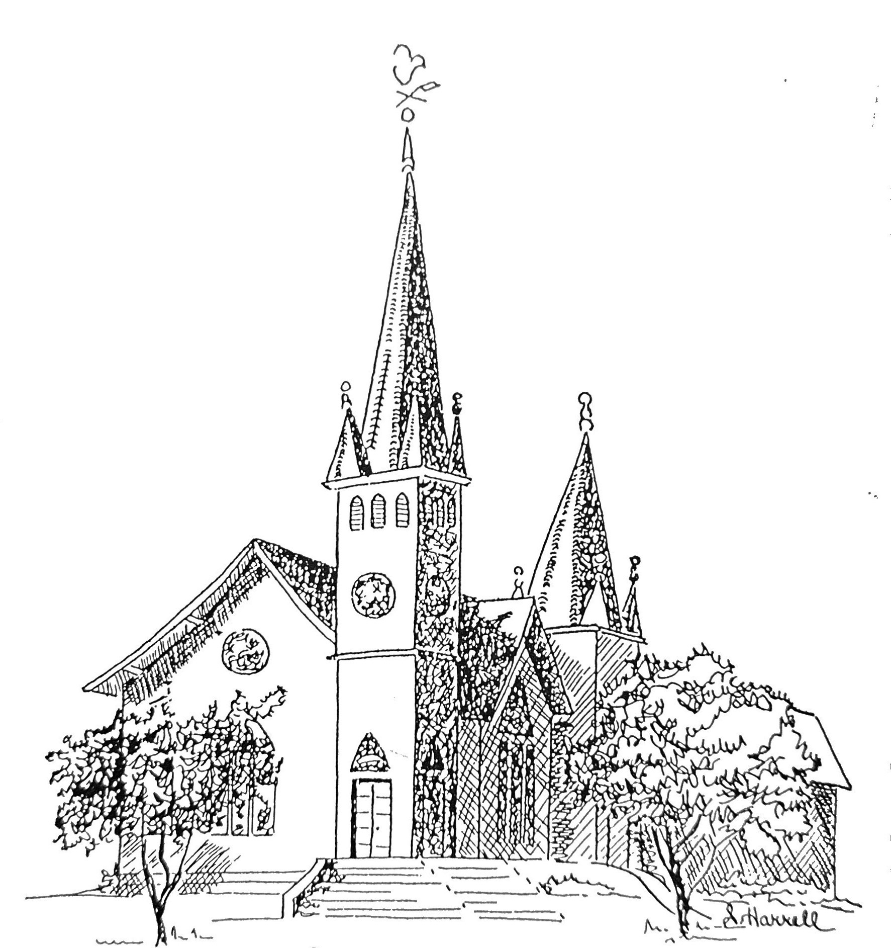
Founded 1877

Brenham Presbyterian Church
Order of Worship
April 7, 2024
Second Sunday of Easter

“For where two or three are gathered in my name, there am I among them.”
(Matthew 18:20)

Welcome and Announcements
The Prelude
Tolling of the Bell

Call to Worship
Leader: May God be gracious to us and bless us and make His face to shine upon us,
People: That your way may be known upon earth, your saving power among
all nations.
Leader: Let the peoples praise you, O God; let all the peoples praise you!
People: Let the nations be glad and sing for joy,
Leader: For you judge the peoples with equity and guide the nations upon earth.
People: Let the peoples praise you, O God; let all the peoples praise you!
Leader: The earth has yielded its increase; God, our God, has blessed us.
People: God has blessed us; let all the ends of the earth fear Him!

* Opening Hymn #434 (The Hymnbook) “Glorious Things of Thee are Spoken”

* Prayer of Adoration (unison)
Almighty God, to whom all hearts are open, all desires known, and from whom no secrets are hid: Cleanse the thoughts of our hearts by the inspiration of your Holy Spirit, that we may perfectly love you and worthily magnify your holy name; through Christ our Lord. Amen

Assurance of Pardon: “See what love the father has given us, that we should be called children of God: and that is what we are.” (I John 3:1)

Prayer of Confession (unison)
Most holy and merciful Father: we confess before you our manifold
failings and sinful ways. You alone know how often we have sinned, in wandering from your ways, in wasting your gifts, in forgetting your love. Your forgiveness and
grace painfully reveal the shadows in which we so often dwell. Have mercy on us.

And grant us that same forgiveness and grace that makes us ashamed and sorry for what we have done and failed to do, so that in its light we might dare again to follow Jesus Christ. In his name we pray. Amen.

The Commandments (unison) “Let love be genuine; hate what is evil, hold fast to what is good; love one another with mutual affection; outdo one another in showing honor. Do not lag in zeal, be ardent in spirit, serve the Lord.” (Romans 12: 9-18)

Musical Reflection

Unison Scripture Reading Selection 55 - Page 527 in the back of The Hymnbook

* Hymn #104 (The Hymnbook) “The Lord’s My Shepherd” (Third Tune)

Prayer for Illumination

Scripture: John 20:19-23

Sermon: "Breathe in the Spirit" Alan Constant

* Affirmation of Faith (unison) This is the good news which we received, in which we stand, and by which we are saved: that Christ died for our sins according to the Scriptures, that he was buried, that he was raised on the third day: and that he appeared to Peter, then to the Twelve and to many faithful witnesses. We believe he is the Christ, the Son of the Living God. He is the First and the Last, the Beginning and the End. He is our Lord and our God. Amen.

* Gloria Patri “Glory Be to the Father” Glory to God Hymnal #581

Prayer of Intercession and The Lord’s Prayer

Congregational Response “Hear Our Prayer, O Lord”

Giving of Tithes and Offerings (Choir Anthem)

* Doxology - Glory to God Hymnal #606

* Prayer of Dedication

* Hymn #833 (Glory to God Hymnal) “O Love That Wilt Not Let Me Go”

