* Prayer of Dedication

* Hymn #719 (Glory to God Hymnal) “Come, Labor On”
* Benediction
* Choral Benediction
The Postlude

Session
Brook Bockhorn Marvin - Christian Education
Scott Carlson - Mission & Benevolence
Elizabeth Smith Lehrmann - Congregational Care
Jerry Newman - Worship
Tom Newman - Building & Grounds
Geneva Aguilar Winkelmann - Fellowship, Church Growth
Clerk to Session: Rosellyn McIver and Interim Treasurer: Todd Gray

Today’s Liturgist: DeDe Eastveld

Our guest minister, Tom Currie is a retired Presbyterian minister. He served as pastor of the Brenham Presbyterian Church from 1976 to 1988. He also served as pastor of First Presbyterian Church in Kerrville, Texas, before becoming dean of Union Presbyterian Seminary’s campus in Charlotte, North Carolina. He and his wife, Peggy, currently live in Georgetown. Their son, Chris, who grew up in this congregation, is the pastor of the St. Charles Ave. Presbyterian Church in New Orleans. Chris and his wife, Stephanie, have three children. The Currie’s daughters, Kate and Anne were also born in Brenham. Kate lives in San Antonio with her husband, Chad, and their two girls, Birdie and Evie. Anne lives and works in Austin.

Our Mission Statement
Gather to worship God and know His Word
Grow in our relationship with God
Go into the world to serve

www.brenhampresbyterian.org

* Congregation please stand

Brenham
Presbyterian Church
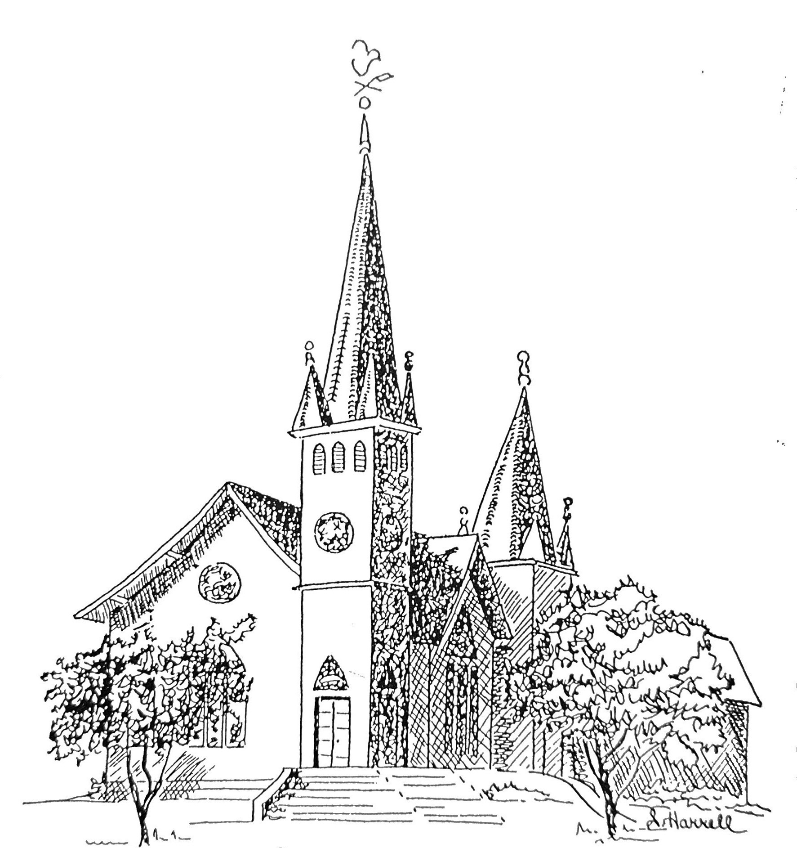
Founded 1877

Brenham Presbyterian Church
Order of Worship
April 14, 2024
Third Sunday of Easter

Welcome and Announcements
The Prelude
Tolling of the Bell

Call to Worship
Leader: O come, let us sing to the Lord;
People: Let us make a joyful noise to the rock of our salvation.
Leader: Let us come into his presence with thanksgiving;
People: Let us make a joyful noise to him with songs of praise.
Leader: Our help is in the name of the Lord who made heaven and earth.
People: Let us worship God. (Psalm 95:1-2; Psalm 124:8)

* Opening Hymn #234 (Glory to God Hymnal) “Come, You Faithful, Raise the Strain”

* Prayer of Adoration (unison)
Grant unto us, O God, the fullness of your promises. Where we have been
weak, grant us your strength; where we have been confused, grant us your
guidance; where we have been distraught, grant us your comfort; where we
have been dead, grant us your life. Apart from you, O Lord, we are nothing. In
and with you, we can do all things, through Jesus Christ our Lord. Amen.

Assurance of Pardon

Prayer of Confession (unison)
Merciful God, we confess that we have sinned against you in thought, word, and
deed, by what we have done, and by what we have left undone. We have not loved
you with our whole heart and mind and strength; we have not loved our neighbors
as ourselves. In your mercy, forgive what we have been, help us amend what we
are, and direct what we shall be, so that we may delight in your will and walk in
your ways to the glory of your holy name. We ask this through Jesus Christ our
Lord. Amen.

The Commandments (unison)
We love God because he first loved us. Those who say, “I love God,” and hate
their brothers or sisters, are liars; for those who do not love a brother or sister
whom they have seen cannot love God whom they have not seen. The
commandment we have from him is this: those who love God must love their
brothers and sisters also. (I John 4:19-21)

Musical Reflection

Responsive Scripture Reading (Selection 9) - Page 476 in the back of The Hymnbook

* Hymn #239 (The Hymnbook) “Come, Holy Spirit, Heavenly Dove”

Prayer of Illumination

Scripture: Acts 3: 11-20

Sermon “Times of Refreshing” Tom Currie

* Hymn #274 (Glory to God Hymnal) “You, Lord, Are Both Lamb and Shepherd”

* Affirmation of Faith: The Apostles’ Creed
I believe in God, the Father Almighty, Maker of heaven and earth. And in Jesus Christ his only Son, our Lord; who was conceived by the Holy Ghost, born of the Virgin Mary, suffered under Pontius Pilate, was crucified, dead, and buried; he descended into hell; the third day he rose again from the dead; he ascended into heaven, and sitteth on the right hand of God the Father Almighty; from thence he shall come to judge the quick and the dead. I believe in the Holy Ghost; the holy catholic church; the communion of saints, the forgiveness of sins; the resurrection of the body; and the life everlasting. Amen.

* Gloria Patri “Glory Be to the Father” Glory to God Hymnal #581

Prayer of Intercession and The Lord’s Prayer

Congregational Response “Hear Our Prayer, O Lord”

Giving of Tithes and Offerings (Choir Anthem)

* Doxology - Glory to God Hymnal #606

