**ALL HYMNS TODAY ARE FROM: “The Hymnbook”**

**********************

Brenham Presbyterian Church

900 South Jackson St.

Brenham, Texas

Mailing Address: 1005 Green Street

Brenham, TX 77833

**Session**

Brook Bockhorn Marvin - Christian Education

Scott Carlson - At Large

Dave Mathis - Congregational Care

- Mission, Benevolence &Visibility

Jerry Newman - Worship

Tom Newman - Building & Grounds

Susan Aguilar - Fellowship

Clerk to Session: Rosellyn McIver and Treasurer: Todd Gray

***Today’s Worship Leaders***

*Liturgist: Lynne Mahood*

*Music Leadership:*

*Jane Barnhill, and*

*Betsy Newman*

Rev. Janell Blair

Cell: 361-920-2492 Office: 979-836-7632

Email: pastor@brenhampresbyterian.org

Our Mission Statement

Gather to worship God and know His Word

Grow in our relationship with God

Go into the world to serve

*\* Congregation please stand www.brenhampresbyterian.org*

*if able*

**Brenham**

**Presbyterian Church**

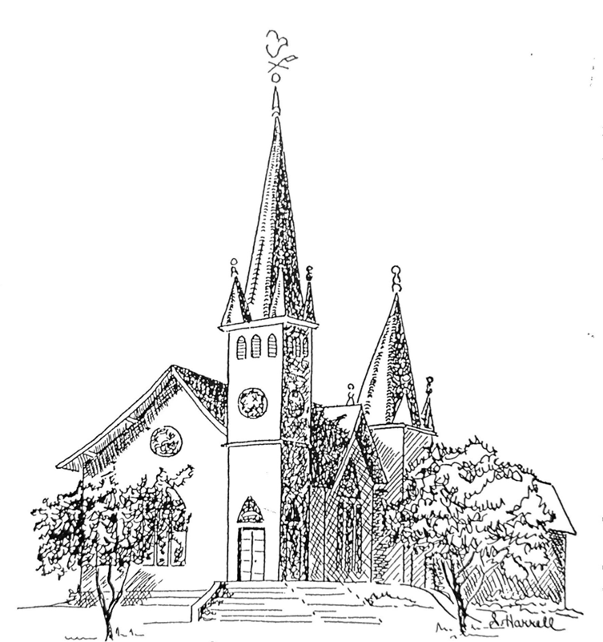

**Brenham Presbyterian Church**

**August 3, 2025**

Welcome and Announcements

The Prelude

Tolling of the Bell

Call to Worship from (Colossians 3)

Leader: You have been raised with Christ, so set your hearts on things above,

**People: Where Christ is seated at the right hand of God.**

Leader: Put on your new self,

**People: Which is being renewed in the image of its Creator.**

**Hymn #26 “O Worship the King,**

*Prayer of Adoration *(unison)*

**O God, you are mighty and eternal, and your Son Jesus Christ fed the hungry with the bread of his life and the Word of his kingdom. Renew us, and in our weakness sustain us by the living bread, Jesus Christ our Lord. Amen.**

Assurance of Pardon

“If God is for us, who can be against us? Nothing can separate us from God’s love.” In Jesus Christ we are forgiven.

Confession of Sin *(unison)*

**Eternal God, our judge and redeemer, we confess that we have tried to hide from you, for we have done wrong. We live for ourselves, and apart from you. We turn from our neighbors, and refuse to bear the burdens of others. We ignore the pain of the world, and pass by the poor and the oppressed. In your great mercy forgive our sins and free us from selfishness, that we may choose your will and obey your commandments; through Christ our Savior. Amen.**

Musical Reflection

Prayer for Illumination

First Scripture: Psalm 107:1-9, 43

**\*Hymn #300 “Take Time to Be Holy”**

Second Scripture: Luke 12:13-21

Sermon “Ingredients” Rev. Janell Blair

**\***Affirmation of Faith The Apostles’ Creed (Hymnbook, page 12)

*Gloria Patri (Hymnbook #546)

Prayer of Intercession and The Lord’s Prayer

Congregational Response “Hear Our Prayer, O Lord”

(Hear our prayer, O Lord; Hear our prayer, O Lord; Incline thine ear to us, and grant us thy peace. Amen.)

Giving of Tithes and Offerings

Offertory

*Doxology (Hymnbook #544)

*Prayer of Dedication

**\*Hymn #442 “Here, O My Lord, I See Thee Face to Face”**

**Sacrament of Communion**

The Invitation to the Lord’s Table

The Great Thanksgiving--

Leader: The Lord be with you**.**

**People: And also, with you.**

Leader: Lift up your hearts.

**People: We lift them up to the Lord.**

Leader: Let us give thanks to the Lord our God.

**People: It is right to give our thanks and praise.**

The Communion of the People

**\*Hymn #443 “A Parting Hymn We Sing”**

*Benediction

*Choral Benediction

The Postlude