Session
Brook Bockhorn Marvin - Christian Education
Scott Carlson - Mission & Benevolence
Elizabeth Smith Lehrmann - Congregational Care
Jerry Newman - Worship
Tom Newman - Building & Grounds
Geneva Aguilar Winkelmann - Fellowship, Church Growth

Clerk to Session: Rosellyn McIver and Interim Treasurer: Todd Gray

Today’s Liturgist: Jayme Ponder

Richard H. Powell, Jr. (Dick) and Lynne Brannon Powell have been married for 47 years. Dick is a graduate of The University of North Carolina-Wilmington with a BA in Philosophy. His first masters level degree work was at the School for Public Policy and International Affairs at NC State University. His second masters level work was at Austin Presbyterian Theological Seminary. He is currently enrolled in the Doctor of Ministry program at Austin seminary. He entered seminary after a 25-year career in the public and private sector. His first call upon graduation from Austin seminary, was as pastor of Forest Hills Presbyterian Church, Helotes, Texas and then was called to Presbyterian Mo-Ranch Assembly as the president and chief executive officer. He retired February 1, 2021. He has served the greater church as Chair of the Committee on Ministry, the Permanent Judicial Committee, and currently as a trustee of Mission Presbytery as well as various admirative commissions. He currently serves on the board and as the chair of the development committee of the Texas Impact Foundation and on the board of the Texas Presbyterian Foundation. Lynne and Dick have two children, Richard, married to Mary Beth, living in Austin, TX and Lizzie, married to Will and living in London, England. They have two perfect grandsons living in Austin and one perfect granddaughter who will live in London.

Our Mission Statement
Gather to worship God and know His Word
Grow in our relationship with God
Go into the world to serve

www.brenhampresbyterian.org

* Congregation please stand

Brenham
Presbyterian Church
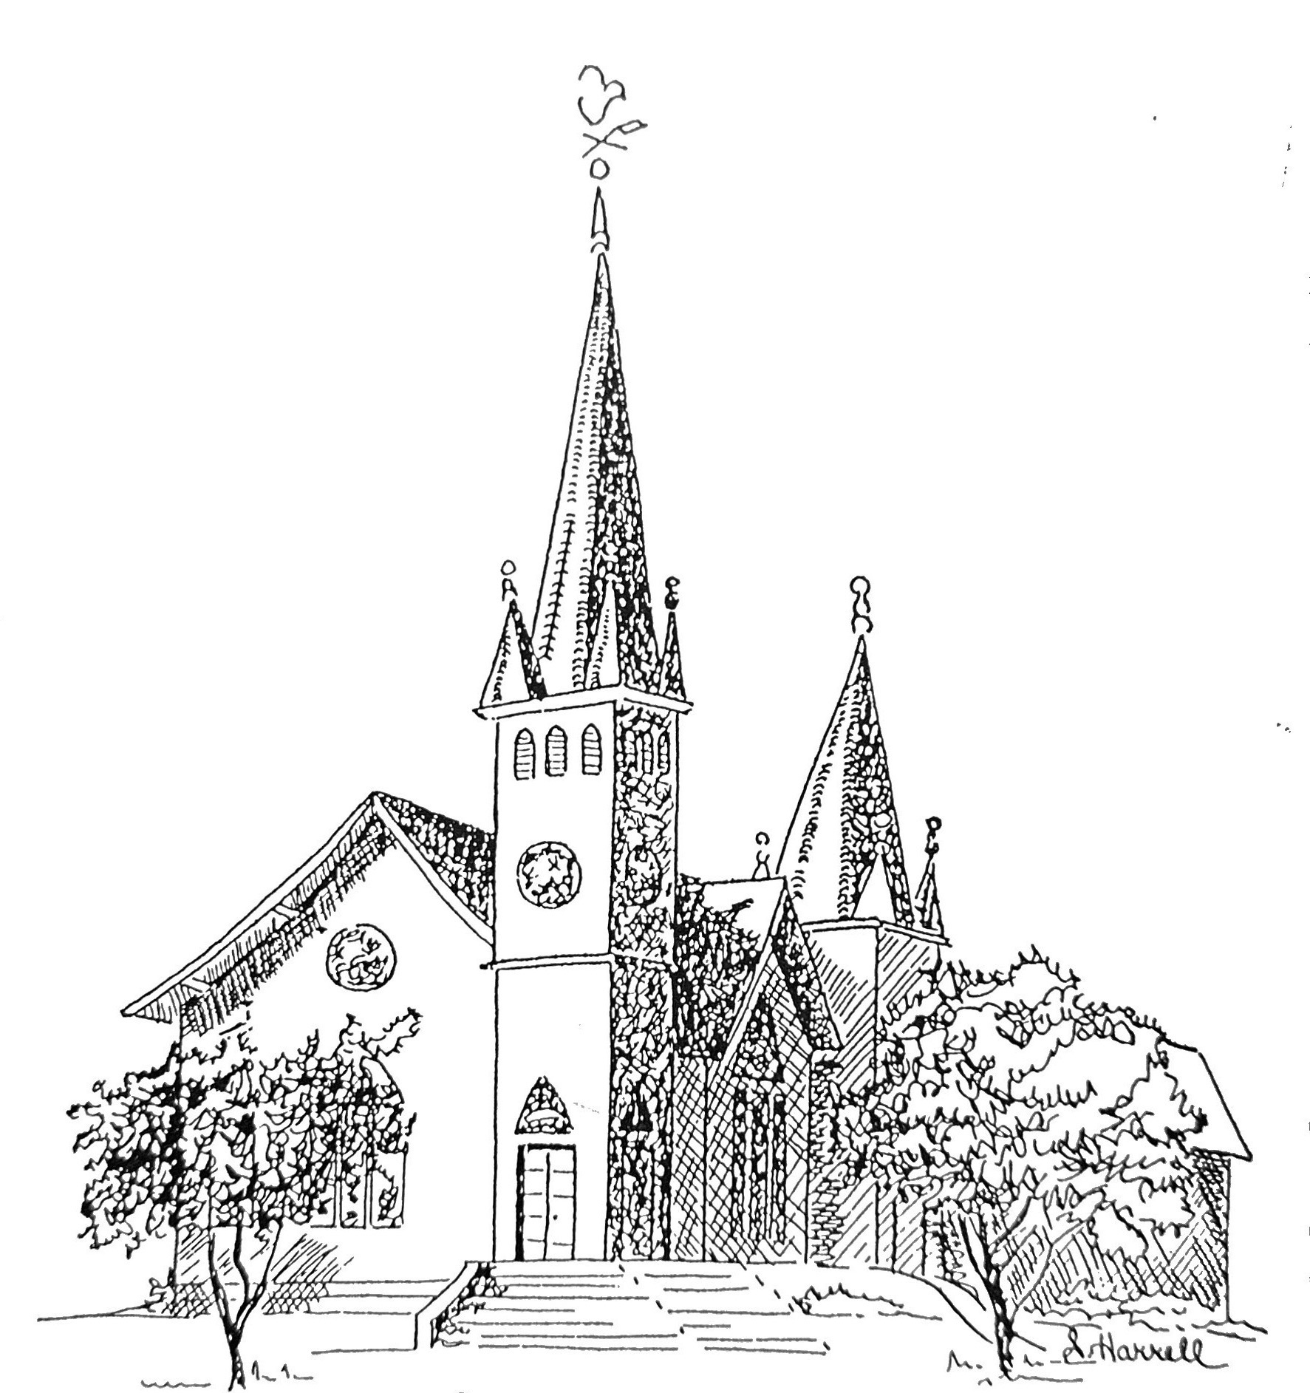
Founded 1877

Brenham Presbyterian Church
Order of Worship
March 17, 2024
Fifth Sunday in Lent

“The Lord is righteous in all his ways and kind in all his works.”
Psalm 145:17

Welcome and Announcements
The Prelude
Tolling of the Bell

Call to Worship (Psalm 100)
Leader: Worship the Lord with gladness; come before him with joyful songs.
People: Know that the Lord is God.
Leader: It is he who made us, and we are his. We are his people, the sheep of his pasture.
People: Enter his gates with thanksgiving and his courts with praise;
Leader: give thanks to him and praise his name.
People: For the Lord is good and his love endures forever;
his faithfulness continues through all generations.

* Opening Hymn #144 (The Hymnbook) “I Greet Thee, Who My Sure Redeemer Art”

* Prayer of Adoration (unison) Gracious God, whose gifts to us are beyond both
our merits and our understanding, pour into our hearts this day a faith that
rejoices in your faithfulness to sinners, so that we may set you above all things
and may discover the gift of gratitude in the very ties that bind us together in
Jesus Christ, in whose name we pray. Amen.

Assurance of Pardon: “Anyone who is in Christ is a new creation. The old life
has gone; a new life has begun.” (2 Corinthians 5:17)

Prayer of Confession (unison) Almighty and most merciful Father: we have erred and strayed from your ways like lost sheep. We have followed too much the devices and desires of our own hearts. We have offended against your holy laws. We have left undone those things which we ought to have done; and we have done those things we ought not to have done; and there is no health in us. Have mercy upon us, O Lord. Spare those who are penitent according to your promises declared unto mankind in Christ Jesus our Lord. And grant, O most merciful Father, for his sake, that we may hereafter live a godly, righteous, and sober life; to the glory of your holy name. Amen.
The Commandments (unison) You shall love the Lord your God with all your heart,
and with all your soul, and with all your mind. This is the first and
great commandment. And the second is like it, You shall love your neighbor
as yourself. (Matthew 22: 37-39)

Musical Reflection

Scripture: Psalm 145 - Responsive Reading (Bulletin Insert)

* Hymn #320 (The Hymnbook) “I Am Thine, O Lord”

Prayer for Illumination

Sermon “The ABCs of Praise” Dick Powell

* Hymn #717 (Glory to God Hymnal) “For the Life That You Have Given”

* Affirmation of Faith (unison) This is the good news which we received, in which we stand, and by which we are saved: that Christ died for our sins according to the Scriptures, that he was buried, that he was raised on the third day: and that he appeared to Peter, then to the Twelve and to many faithful witnesses. We believe he is the Christ, the Son of the Living God. He is the First and the Last, the Beginning and the End. He is our Lord and our God. Amen.

* Gloria Patri “Glory Be to the Father” Glory to God Hymnal #581

Prayer of Intercession and The Lord’s Prayer

Congregational Response “Hear Our Prayer, O Lord”

Giving of Tithes and Offerings (Choir Anthem)

* Doxology - Glory to God Hymnal #606
* Prayer of Dedication

* Hymn #196 (Glory to God Hymnal) “All Glory, Laud, and Honor”

* Benediction
* Choral Benediction
The Postlude

