* Prayer of Dedication
* Hymn #815 (Glory to God Hymnal) “Give to the Winds Thy Fears”
* Benediction
* Choral Benediction
The Postlude

Session
Brook Bockhorn Marvin - Christian Education
Scott Carlson - Mission & Benevolence
Elizabeth Smith Lehrmann - Congregational Care
Jerry Newman - Worship
Tom Newman - Building & Grounds
Geneva Aguilar Winkelmann - Fellowship, Church Growth

Clerk to Session: Rosellyn McIver and Interim Treasurer: Todd Gray

Today’s Liturgist: Robert Lake

Our guest minister, Tom Currie is a retired Presbyterian minister. He served as pastor of the Brenham Presbyterian Church from 1976 to 1988. He also served as pastor of First Presbyterian Church in Kerrville, Texas, before becoming dean of Union Presbyterian Seminary’s campus in Charlotte, North Carolina. He and his wife, Peggy, currently live in Georgetown. Their son, Chris, who grew up in this congregation, is the pastor of the St. Charles Ave. Presbyterian Church in New Orleans. Chris and his wife, Stephanie, have three children. The Currie’s daughters, Kate and Anne were also born in Brenham. Kate lives in San Antonio with her husband, Chad, and their two girls, Birdie and Evie. Anne lives and works in Austin.

Our Mission Statement
Gather to worship God and know His Word
Grow in our relationship with God
Go into the world to serve

www.brenhampresbyterian.org

* Congregation please stand

Brenham
Presbyterian Church
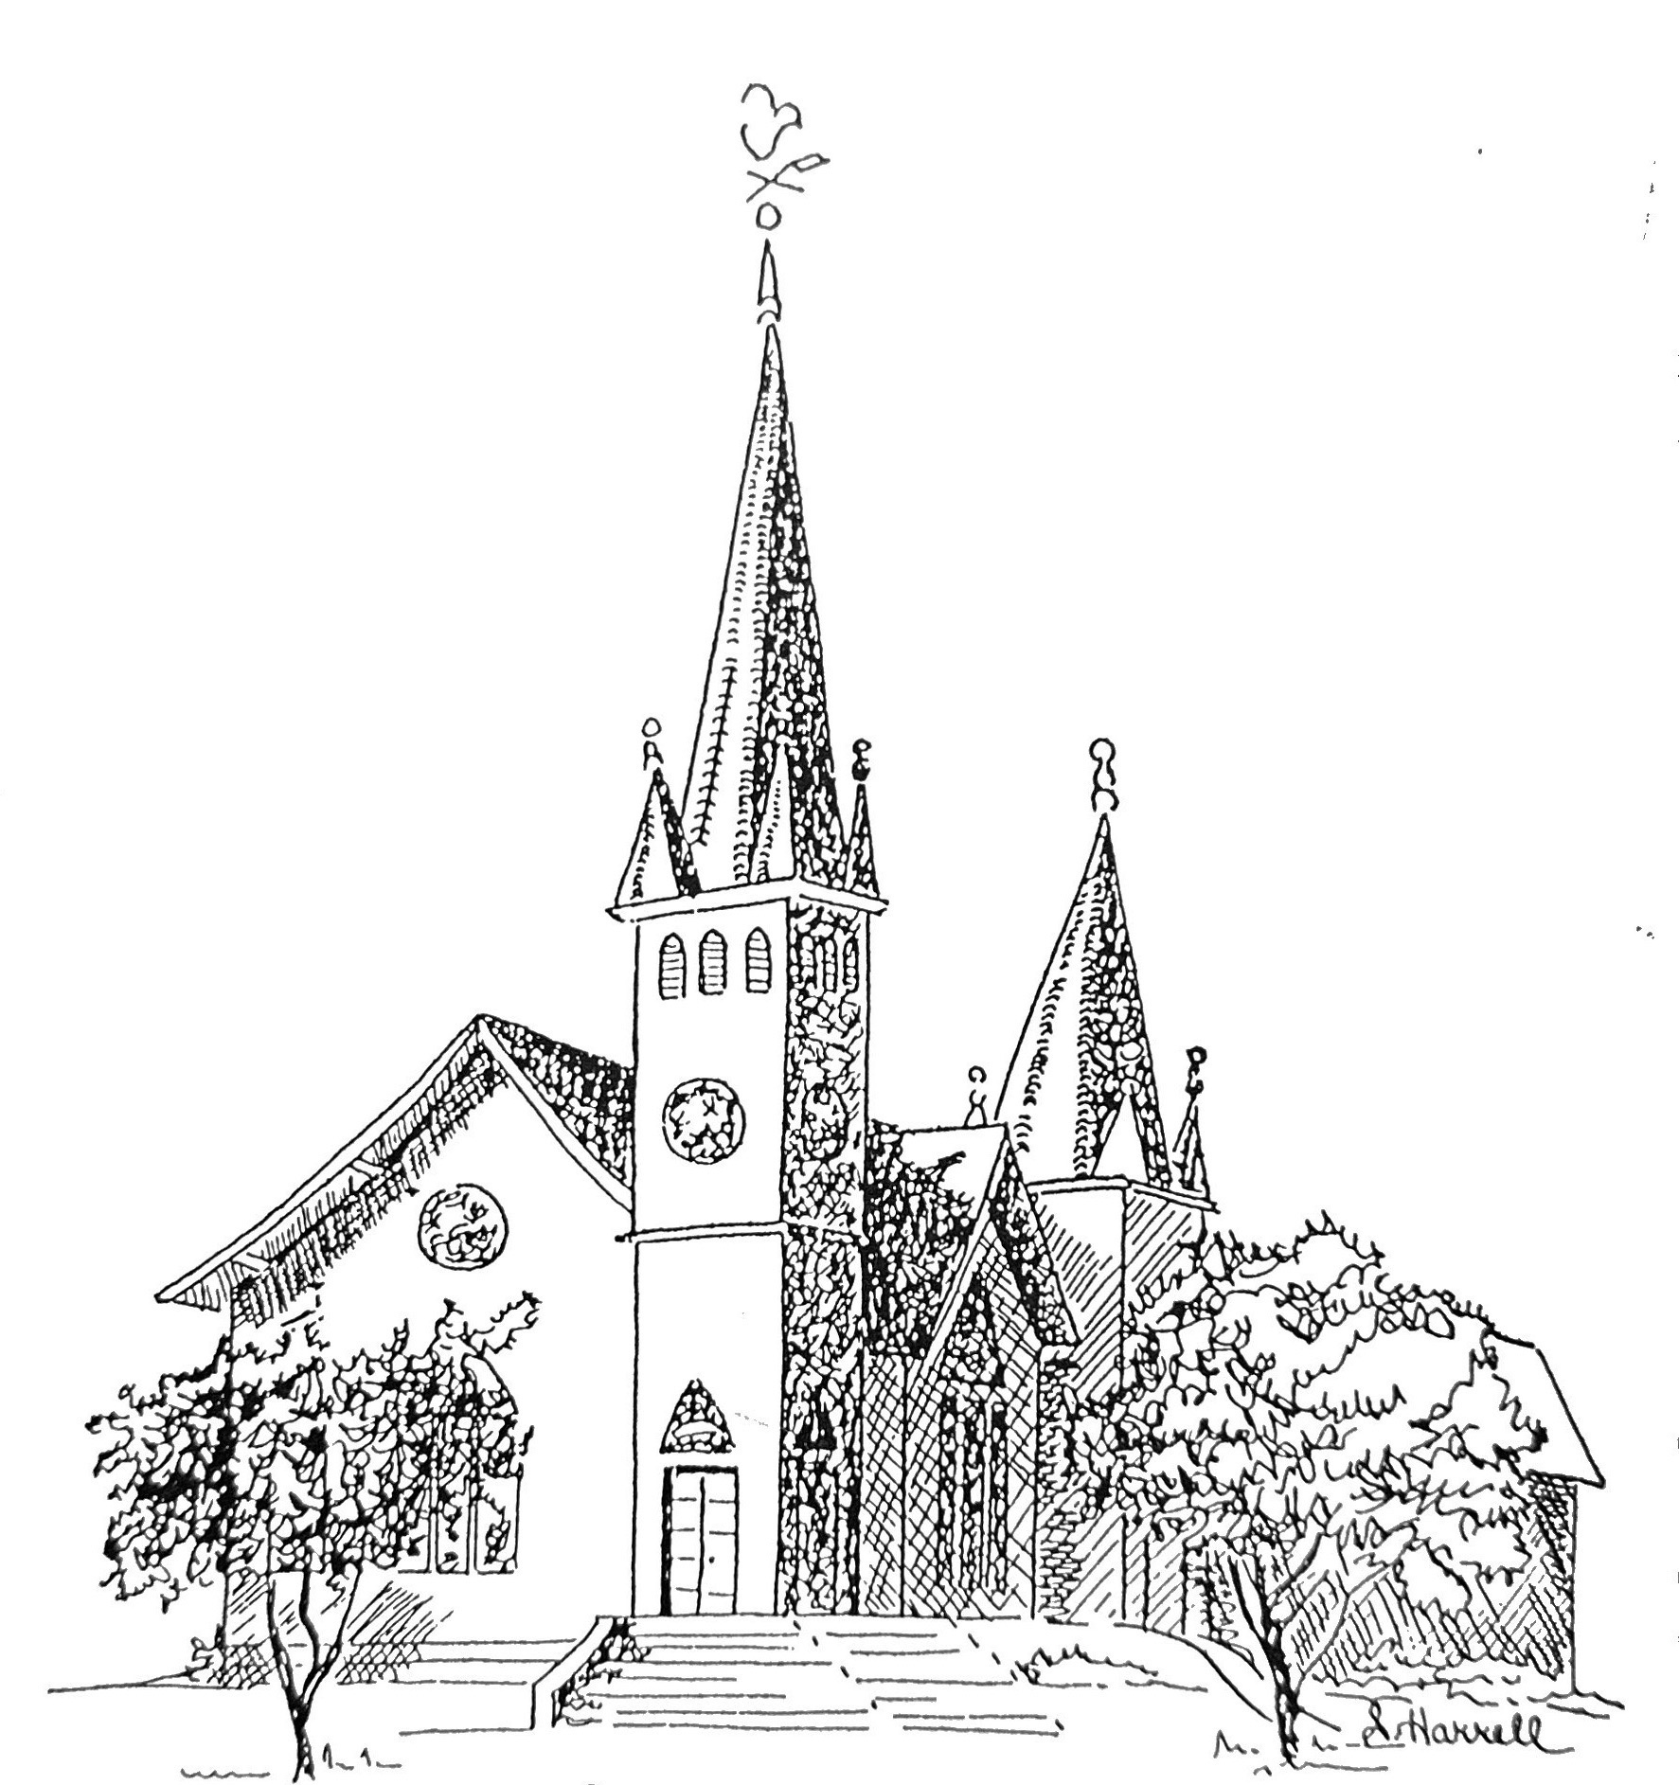
Founded 1877

Brenham Presbyterian Church
Order of Worship
March 10, 2024
Fourth Sunday in Lent

Welcome and Announcements
The Prelude
Tolling of the Bell

Call to Worship
Leader: The Lord is faithful in all his words, and gracious in all his deeds. People: The Lord upholds all who are falling and raises up all who are bowed down. Leader: The eyes of all look to you, and you give them their food in due season. People: You open your hand satisfying the desire of every living thing. Leader: Our help is in the name of the Lord, who made heaven and earth. People: Let us worship God. (Ps.145:13-16; Ps.124:8)

* Opening Hymn #620 (Glory to God Hymnal) “Praise, My Soul, the King of Heaven”

* Prayer of Adoration (unison) Almighty and everlasting God, you are more ready
to hear than we to pray, and you give us more than we desire or deserve: Pour
down upon us the abundance of your mercy so that we might worship you aright
and gladly voice our praise and thanksgiving. We ask this in the name of our
Lord and Savior, Jesus Christ. Amen.

Assurance of Pardon: “Or what woman having ten silver coins, if she loses one of
them, does not light a lamp, sweep the house, and search carefully until she finds it?
When she has found it, she calls together her friends and neighbors, saying, ‘Rejoice
with me, for I have found the coin that I lost.’ Just so, I tell you, there is joy in the
presence of the angels of God over one sinner who repents.” (Luke 15: 8-10)

Prayer of Confession (unison) Eternal God, our Judge and Redeemer: we confess
that we have tried to hide from you by loving the darkness more than the light.
We have lived self-centered lives and have daily attempted to deceive ourselves and you. Forgive us. Grant us faith to live in your light and walk in your ways and to be unashamed to be called your children. We ask this in the name of him who welcomed sinners and ate with them, even Jesus Christ our Lord. Amen.

The Commandments (unison) “Which of these three, do you think, was a neighbor to
the man who fell into the hands of the robbers? He said, ‘The one who showed
him mercy.’ Jesus said to him, ‘Go and do likewise.’” (Luke 10: 36,37)

Musical Reflection

Responsive Scripture Reading (Selection 26) - Page 496 in the back of The Hymnbook

* Hymn #166 (Glory to God Hymnal) “Lord, Who throughout These Forty Days”

Prayer of Illumination

Scripture: Ephesians 2:1-10

Sermon “Our Magna Carta” Tom Currie

* Hymn #649 (Glory to God Hymnal) “Amazing Grace”

* Affirmation of Faith (unison) I believe in God, the Father Almighty, Maker of heaven
and earth. And in Jesus Christ his only Son, our Lord; who was conceived by
the Holy Ghost, born of the Virgin Mary, suffered under Pontius Pilate,
was crucified, dead, and buried; he descended into hell; the third day he rose
again from the dead; he ascended into heaven, and sitteth on the right hand of
God the Father Almighty; from thence he shall come to judge the quick and
the dead. I believe in the Holy Ghost; the holy catholic church; the forgiveness
of sins; the resurrection of the body; and the life everlasting. Amen.

* Gloria Patri “Glory Be to the Father” Glory to God Hymnal #581

Prayer of Intercession and The Lord’s Prayer

Congregational Response “Hear Our Prayer, O Lord”

Giving of Tithes and Offerings (Choir Anthem)

* Doxology - Glory to God Hymnal #606

