Session
Brook Bockhorn Marvin - Christian Education
Scott Carlson - Mission & Benevolence
Elizabeth Smith Lehrmann - Congregational Care
Jerry Newman - Worship
Tom Newman - Building & Grounds
Geneva Aguilar Winkelmann - Fellowship, Church Growth
Clerk to Session: Rosellyn McIver and Interim Treasurer: Todd Gray

Today’s Liturgist: George Newman

Our guest minister, Tom Currie is a retired Presbyterian minister. He served as pastor of the Brenham Presbyterian Church from 1976 to 1988. He also served as pastor of First Presbyterian Church in Kerrville, Texas, before becoming dean of Union Presbyterian Seminary’s campus in Charlotte, North Carolina. He and his wife, Peggy, currently live in Georgetown. Their son, Chris, who grew up in this congregation, is the pastor of the St. Charles Ave. Presbyterian Church in New Orleans. Chris and his wife, Stephanie, have three children. The Currie’s daughters, Kate and Anne were also born in Brenham. Kate lives in San Antonio with her husband, Chad, and their two girls, Birdie and Evie. Anne lives and works in Austin.

Our Mission Statement
Gather to worship God and know His Word
Grow in our relationship with God
Go into the world to serve

www.brenhampresbyterian.org

* Congregation please stand

Brenham
Presbyterian Church
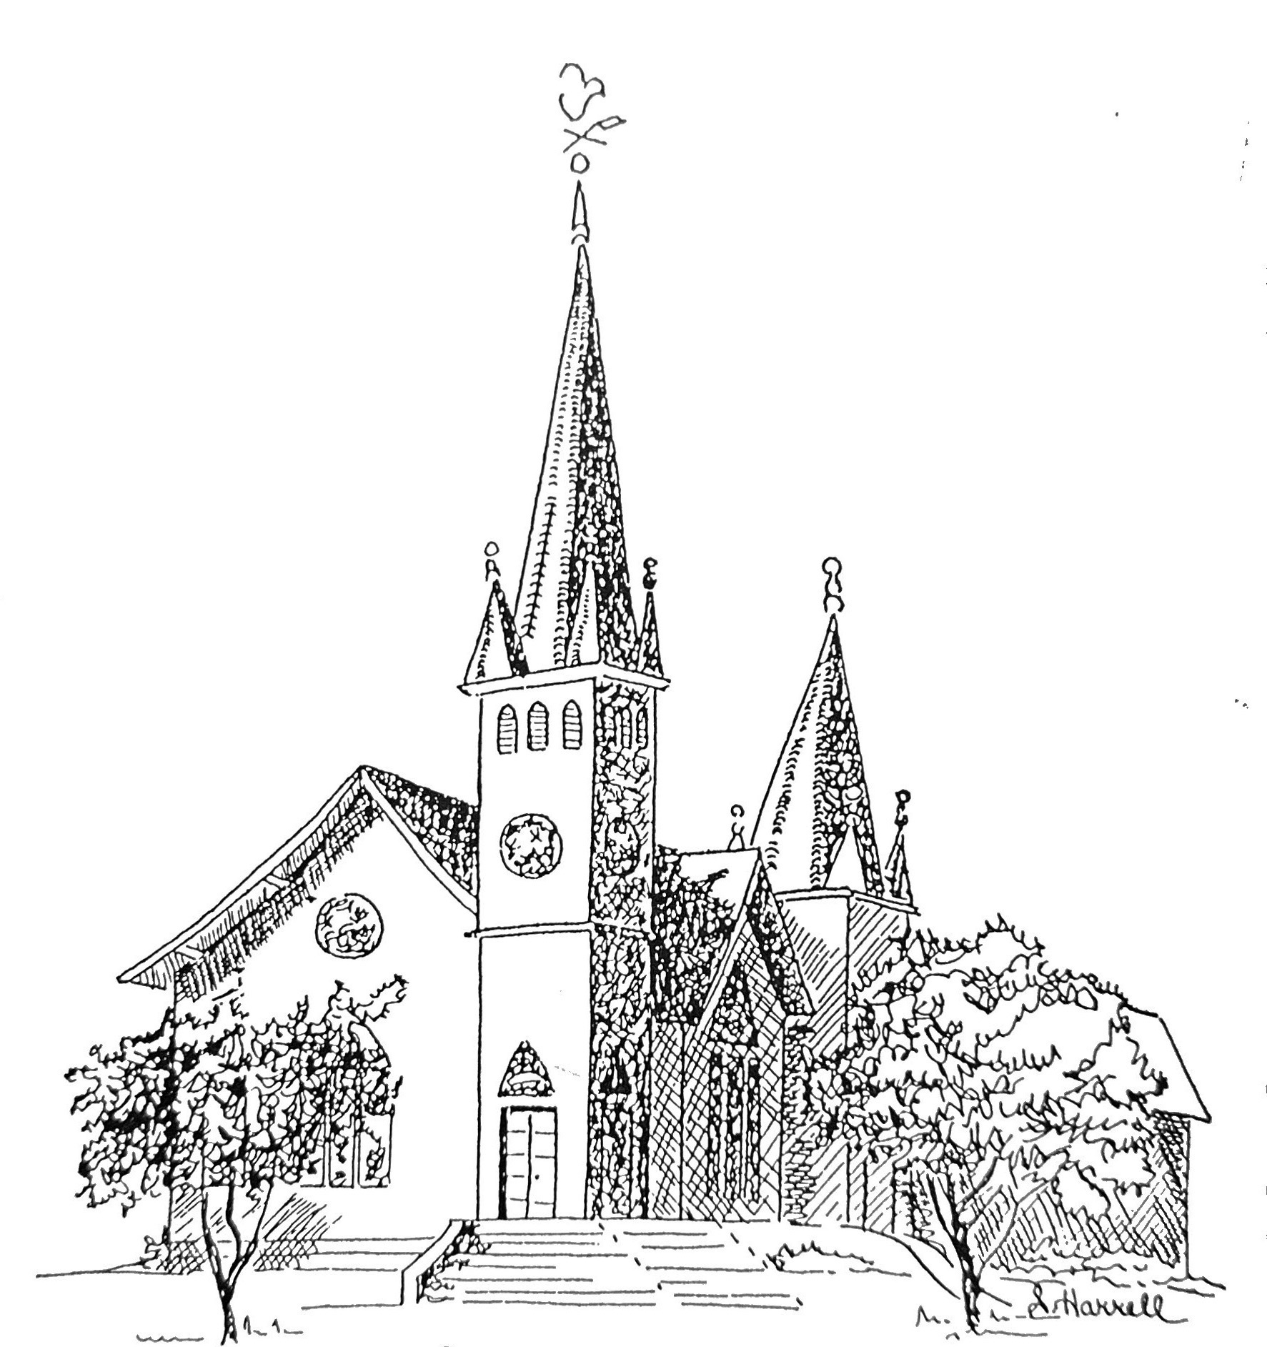
Founded 1877

Brenham Presbyterian Church
Order of Worship
March 31, 2024
Resurrection of Our Lord

Welcome and Announcements
The Prelude
Tolling of the Bell

Call to Worship
Leader: O give thanks to the Lord, for he is good;
People: For his steadfast love endures forever!
Leader: The Stone that the builders rejected has become the chief cornerstone.
People: This is the Lord’s doing; it is marvelous in our eyes.
Leader: This is the day that the Lord has made;
People: Let us rejoice and be glad in it.
Leader: Our help is in the name of the Lord.
People: Let us worship God. (Psalm 118:1, 22, 23, and Psalm 124:8)

* Opening Hymn #232 (Glory to God Hymnal) “Jesus Christ Is Risen Today”

* Prayer of Adoration (unison) Almighty God, who through your only-begotten
Son Jesus Christ overcame death and opened to us the gate of everlasting life:
Grant that we, who celebrate with joy the day of the Lord’s resurrection, may
be raised from the death of sin by your life-giving Spirit; through Jesus Christ
our Lord; who lives and reigns with you and the Holy Spirit, one God, now
and forever. Amen

Assurance of Pardon: “See what love the Father has given us, that we should be
called children of God; and that is what we are.” (I John 3:1)

Prayer of Confession (unison) Almighty and most merciful Father: we have erred and strayed from your ways like lost sheep. We have followed too much the devices and desires of our own hearts. We have offended against your holy laws. We have left undone those things which we ought to have done; and we have done those things which we ought not to have done; and there is no health in us. Have mercy upon us,
O Lord. Spare those who are penitent according to your promises declared unto
mankind in Christ Jesus our Lord. And grant, O most merciful Father, for his sake, that we may hereafter live a godly, righteous, and sober life; to the glory of
your holy name. Amen.

The Commandments (unison) “The commandment we have from him is this: those
who love God must love their brothers and sisters also.” ( I John 3:21)

Musical Reflection

Responsive Scripture Reading (Selection 23) - Page 494 in the back of The Hymnbook

* Hymn #254 (Glory to God Hymnal) “That Easter Day with Joy Was Bright”

Prayer of Illumination

Scripture: I Corinthians 15:1-28

Sermon “The Last Enemy” Tom Currie

* Hymn #250 (Glory to God Hymnal) “In the Bulb There Is a Flower”

* Affirmation of Faith: The Nicene Creed (Page 34 in the front of Glory to God Hymnal)

* Gloria Patri “Glory Be to the Father” Glory to God Hymnal #581

Prayer of Intercession and The Lord’s Prayer

Congregational Response “Hear Our Prayer, O Lord”

Giving of Tithes and Offerings (Choir Anthem)

* Doxology - Glory to God Hymnal #606

* Prayer of Dedication

* Hymn #265 (Glory to God Hymnal) “Jesus Shall Reign Where’er the Sun”

* Benediction
* Choral Benediction
The Postlude

